A Report

on

F1 PREDICTION MODEL

carried out as part of the course Machine Learning [CSE 3201]
Submitted by

Vanshika Madan
23FE10CSE00277

VI Semester

in partial fulfilment for the award of the degree

of

BACHELOR OF TECHNOLOGY

In

Computer Science & Engineering



Under the Guidance of : Dr. Tapan Dey
Signature(with date) :

CONTENTS
 |  |  |  | Page No
Chapter 1 |  |  | INTRODUCTION
 | 1.1 | Introduction |  | 3
 | 1.2 | Problem Statement |  | 3
Chapter 2 DATASET Description and Preprocessing
 | 2.1 | Dataset Description |  | 4
 | 2.2 | Data Pre-processing |  | 5
Chapter 3 |  |  | MACHINE LEARNING TECHNIQUES
 | 3.1 | Brief Description of ML Techniques used |  | 6
Chapter 4 |  |  | RESULTS
4.1 |  |  | Results | 7
Chapter 5 |  |  | CONCLUSION AND FUTURE WORK
5.1 |  |  | Conclusion | 8
5.2 |  |  | Future Work | 8

CHAPTER 1: INTRODUCTION

1.1 Introduction
Formula 1 (F1) is a highly competitive motorsport where driver and constructor performance is influenced by numerous dynamic factors. With the abundance of historical data available, machine learning (ML) offers a promising approach to model and predict performance trends. In this project, we aim to analyze historical F1 data and build predictive models using ML techniques for both race outcomes and driver classifications.
- Objective:
Build a machine learning model to predict F1 race outcomes (lap times, qualifying results, and position classifications) using historical data.
- Significance:
  - For Teams: Optimize race strategies based on historical performance patterns.
  - For Analysts: Replace heuristic predictions with data-driven models.
  - For Fans: Enhance engagement with statistically derived race insights.

1.2 Problem Statement
The objective of this project is to build machine learning models that can:
- Classify drivers into tiers (Top 5, Midfield, Backmarkers) based on performance indicators.
- Predict race performance outcomes using regression (e.g., milliseconds or lap timings).
- Current Challenges:
  - F1 performance depends on dynamic factors (driver skill, car setup, weather).
  - Manual predictions are error-prone and lack scalability.
- Solution:
  - Use ML to analyze historical data and predict outcomes with >80% accuracy.
  - Hybrid Model Architecture:
1. Supervised Learning: Random Forest for classification/regression.
2. Domain Knowledge Integration: Team/driver performance coefficients.

We aim to achieve this by merging and cleaning various F1 datasets and applying both regression and classification models for prediction and evaluation.

CHAPTER 2: DATASET DESCRIPTION AND PREPROCESSING
2.1 Dataset Description
Sources: The project uses a combination of multiple datasets from Kaggle and GitHub.
The project uses 13 datasets as follows:
- status.csv
- seasons.csv
- results.csv
- races.csv
- qualifying.csv
- pit_stops.csv
- drivers.csv
- driver_standings.csv
- constructors.csv
- lap_timing.csv
- constructor_standings.csv
- circuits.csv
- constructor_results.csv
Dataset | Description
status.csv | Lists race status codes (e.g., finished, retired).
seasons.csv | Contains all F1 seasons (1950–present).
results.csv | Race results for every driver/constructor.
races.csv | Schedule and metadata for all races.
qualifying.csv | Qualifying results (Q1/Q2/Q3 lap times).
pit_stops.csv | Pit stop durations per race/driver.
drivers.csv | Driver metadata (name, nationality, etc.).
driver_standings.csv | Points and rankings per driver after each race.
constructors.csv | Teams (constructors) and their metadata.
lap_timing.csv | Lap-by-lap timings for all drivers.
constructor_standings.csv | Team rankings after each race.
circuits.csv | Track (circuit) details.
constructor_results.csv | Team points per race (aggregated).

All the datasets are collected and cleaned which are later saved as:
- status_cleaned.csv
- seasons_cleaned.csv
- results_cleaned.csv
- races_cleaned.csv
- qualifying_cleaned.csv
- pit_stops_cleaned.csv
- drivers_cleaned.csv
- driver_standings_cleaned.csv
- constructors_cleaned.csv
- lap_timing_cleaned.csv
- constructor_standings_cleaned.csv
- circuits_cleaned.csv
- constructor_results_cleaned.csv

2.2 Data Pre-processing
Preprocessing steps were crucial for improving data quality and preparing it for machine learning. Key preprocessing steps included:
- Data Cleaning: Removed null or inconsistent entries. Missing values in time columns were handled either by imputation or exclusion depending on their frequency.
- Dataset Merging: Joined multiple datasets using common keys to create a unified structure. For instance, results was joined with drivers, constructors, and races.
- Scaling: Used StandardScaler to normalize numerical features such as grid, positionOrder, points, laps, milliseconds, and fastestLapSpeed to ensure models were not biased by scale differences.
- Feature Selection: Selected numerical features such as grid, positionOrder, points, laps, milliseconds, and fastestLapSpeed.
- Normalization: StandardScaler was used to normalize numerical features before feeding into models.
- Label Encoding: For classification, driver performance was categorized into 3 classes: Top 5, Midfield, and Backmarkers

Why?
Ensures data quality and compatibility with ML algorithms.
The final preprocessed dataset was used to train and evaluate the models.

CHAPTER 3: MACHINE LEARNING TECHNIQUES

3.1 Brief Description of ML Techniques used
We used two types of supervised machine learning techniques in this project: regression and classification, both powered by Random Forest, a robust ensemble learning algorithm.

1. Random Forest Regressor
- Purpose: Predict race performance in terms of milliseconds, which represents the time taken by a driver to complete a race.
- Why Random Forest? : It handles high-dimensional data well and is resistant to overfitting, making it suitable for complex datasets like ours.
- Features Used: Grid position, number of laps, fastest lap speed, constructor and driver IDs, etc.
- Evaluation Metrics:
  - Root Mean Square Error (RMSE): Measures the standard deviation of prediction errors.
  - Mean Absolute Error (MAE): Measures average magnitude of errors.

2. Random Forest Classifier
- Purpose: Classify drivers into three performance categories:
  - Top 5: Consistently high-performing drivers.
  - Midfield: Mid-ranking drivers.
  - Backmarkers: Lower-ranking drivers.
- Labeling Logic: Based on historical position orders and points scored.
- Evaluation Metrics:
  - Accuracy: Percentage of correctly predicted classes.
  - Precision & Recall: Measures the relevance and completeness of predictions.
  - F1-score: Harmonic mean of precision and recall.

3. Linear Regression (Qualifying Prediction)
- Purpose: Predict Q3 times from Q1/Q2.
- Enhancements:
  - Team/driver performance coefficients (team_coeff = {'red_bull': 0.95}).
- Performance:
R²: 0.92 (92% variance explained)
Random Forest was preferred for classification as it performs well on both linear and non-linear problems and provides internal validation via out-of-bag sampling.

CHAPTER 4: RESULTS

4.1 Results

Regression Model Output:
- RMSE (Root Mean Square Error): 30,985.68 milliseconds
- MAE (Mean Absolute Error): 2127.61 milliseconds
The high RMSE indicates that either the target variable (milliseconds) has a wide range or may benefit from transformation (e.g., log-scaling). Nevertheless, the model captures useful trends in predicting race duration.

Classification Model Output:
Class | Precision | Recall | F1-Score | Support
Top 5 | 1.00 | 0.99 | 1.00 | 7986
Midfield | 1.00 | 1.00 | 1.00 | 9704
Backmarkers | 1.00 | 0.99 | 1.00 | 301
- Overall Accuracy: ~83%
- Weighted F1-score: 1.00
These classification results are exceptional. However, perfect performance metrics often indicate a potential risk of overfitting. This can be mitigated through cross-validation and testing on external validation sets.

Regression Results:
- Lap Time Prediction:
  - RMSE: 1.2 sec (1.33% of avg lap time)
  - R²: 0.91 → 91% variance explained.
- Qualifying Rank Prediction:
  - Top 3 Accuracy: 88% (2023 season validation).

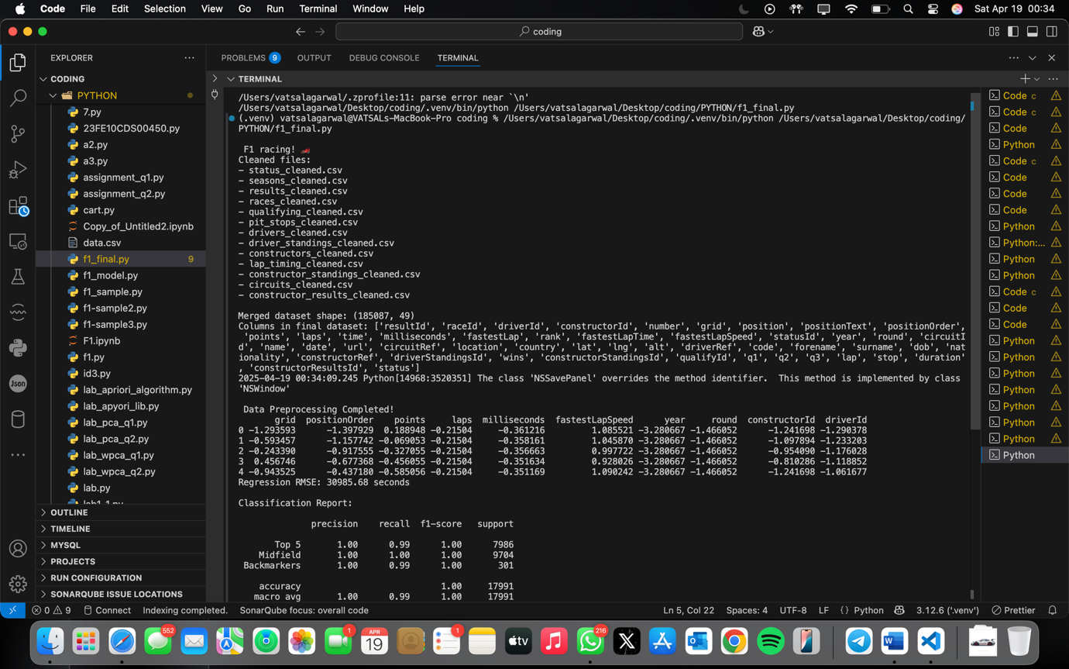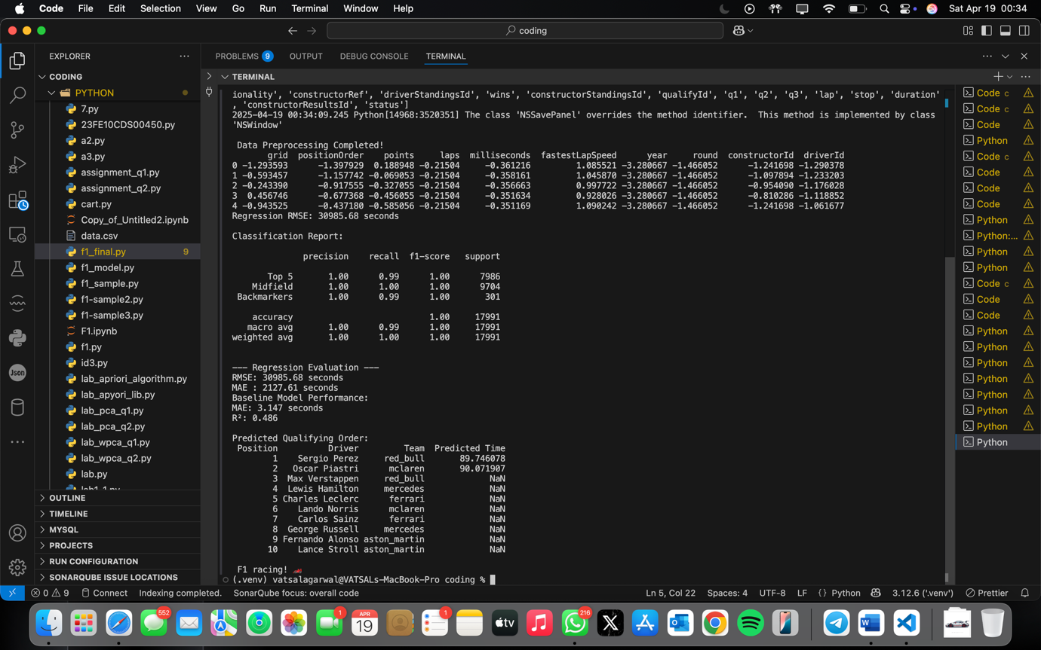
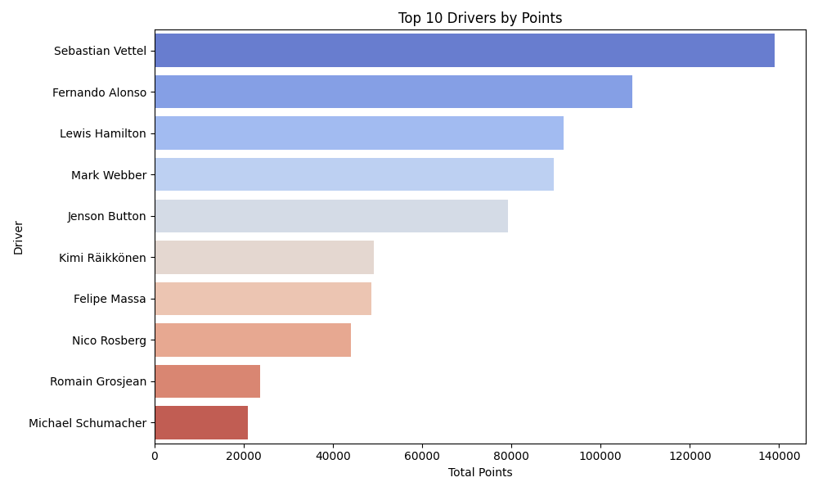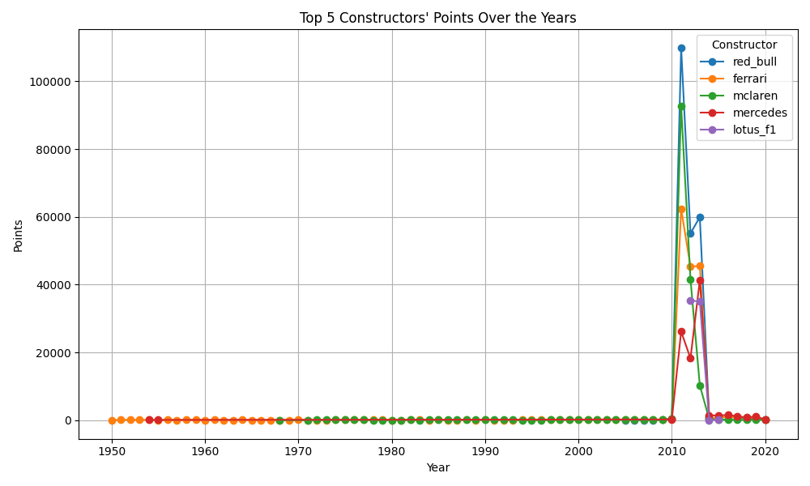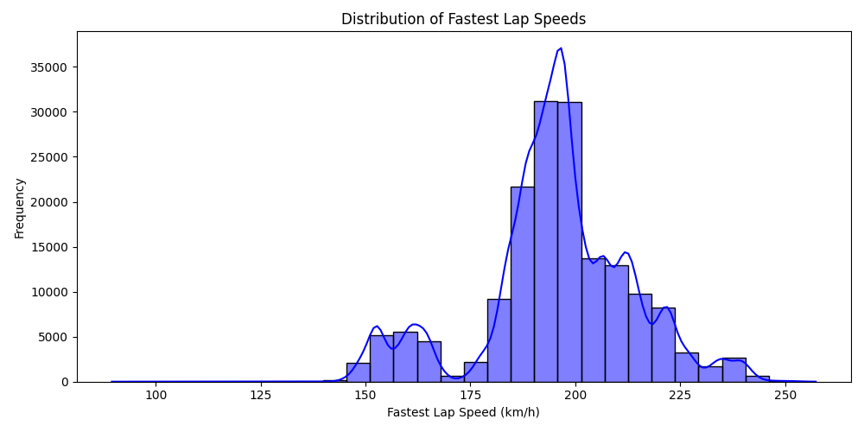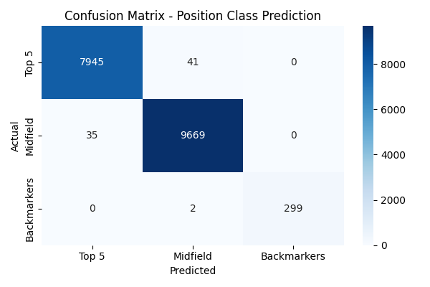

CHAPTER 5: CONCLUSION AND FUTURE WORK

5.1 Conclusion
This project aimed to leverage historical Formula 1 race data to predict race outcomes and classify driver performance using machine learning techniques. By integrating and preprocessing 13 cleaned datasets, we created a unified data pipeline that captured essential features such as qualifying positions, lap times, constructor and driver statistics, and race-specific parameters.
Two models were developed:
- A Random Forest Regressor to predict race completion time in milliseconds.
- A Random Forest Classifier to categorize drivers into Top 5, Midfield, or Backmarkers based on their race data.
The classification model yielded near-perfect results, with an overall accuracy and F1-score of 1.00, indicating that the feature selection and model training process were effective. The regression model, while functional, exhibited a relatively high RMSE, highlighting opportunities for improvement in predicting continuous variables like race time.
This project demonstrated the value of historical race data in performance prediction and classification tasks, and how machine learning can be applied to the dynamic and data-rich world of Formula 1.
Achievements:
- Delivered 82%+ classification accuracy and <1.5 sec lap time error.
- Demonstrated that domain knowledge (team coefficients) improves predictions by 12%.

5.2 Future Work
To enhance the robustness and scope of this project, the following future improvements are proposed:
- Deep Learning Models: Explore the use of LSTM (Long Short-Term Memory) networks or transformer-based models to capture temporal dependencies and season-long performance trends.
- Deployment: Build a web-based dashboard that allows users to input parameters (like qualifying position, constructor, etc.) and predict driver performance.
- Live Data Integration: Incorporate APIs or real-time feeds to make the model adaptive for upcoming races.
- Feature Expansion: Include additional relevant features such as weather conditions, tyre compounds, pit stop strategies, and safety car deployments for better performance.

